**INTERNET OF THINGS**

**WHAT IS IOT?**

The Internet of Things (IoT) describes the network of physical objects “things” that are embedded with sensors, software, and other technologies for the purpose of connecting and exchanging data with other devices and systems over the internet. These devices range from ordinary household objects to sophisticated industrial tools.

**Why is Internet of Things (IoT) so important?**

Over the past few years, IoT has become one of the most important technologies of the 21st century. Now that we can connect everyday objects like kitchen appliances, cars, thermostats, baby monitors—to the internet via embedded devices, seamless communication is possible between people, processes, and things.

By means of low-cost computing, the cloud, big data, analytics, and mobile technologies, physical things can share and collect data with minimal human intervention. In this hyperconnected world, digital systems can record, monitor, and adjust each interaction between connected things. The physical world meets the digital world—and they cooperate.

## What technologies have made IoT possible?

While the idea of IoT has been in existence for a long time, a collection of recent advances in a number of different technologies has made it practical.

* **Access to low-cost, low-power sensor technology.** Affordable and reliable sensors are making IoT technology possible for more manufacturers.
* **Connectivity.** A host of network protocols for the internet has made it easy to connect sensors to the cloud and to other “things” for efficient data transfer.

## What industries can benefit from IoT?

Organizations best suited for IoT are those that would benefit from using sensor devices in their business processes.

**Manufacturing**

Manufacturers can gain a competitive advantage by using production-line monitoring to enable proactive maintenance on equipment when sensors detect an impending failure. Sensors can actually measure when production output is compromised. With the help of sensor alerts, manufacturers can quickly check equipment for accuracy or remove it from production until it is repaired. This allows companies to reduce operating costs, get better uptime, and improve asset performance management.

**Transportation and Logistics**

Transportation and logistical systems benefit from a variety of IoT applications. Fleets of cars, trucks, ships, and trains that carry inventory can be rerouted based on weather conditions, vehicle availability, or driver availability, thanks to IoT sensor data. The inventory itself could also be equipped with sensors for track-and-trace and temperature-control monitoring. The food and beverage, flower, and pharmaceutical industries often carry temperature-sensitive inventory that would benefit greatly from IoT monitoring applications that send alerts when temperatures rise or fall to a level that threatens the product.

**Healthcare**

IoT asset monitoring provides multiple benefits to the healthcare industry. Doctors, nurses, and orderlies often need to know the exact location of patient-assistance assets such as wheelchairs. When a hospital’s wheelchairs are equipped with IoT sensors, they can be tracked from the IoT asset-monitoring application so that anyone looking for one can quickly find the nearest available wheelchair. Many hospital assets can be tracked this way to ensure proper usage as well as financial accounting for the physical assets in each department.

**CASE STUDY:**

FAMOSA is an Italian company that works on technology-based support for agriculture, offering solutions for **crop monitoring and management**. They have developed wireless sensor networks, based on Libelium technology, in a kiwi plantation with GPRS and Sigfox to **develop accurate irrigation strategies for farmers**.

**Comparing GPRS to Sigfox**

Kiwifruit is one of the **most sensitive fruits in terms of quality** which is given by size, sweetness and dry matter. In order to reach the best quality, they considers that it is essential for farmers to develop a good irrigation strategy **to attain marketable products and to reduce product losses**.

Agriculture organizations are deploying cutting-edge technologies in their plantations **to improve processes, to maintain high quality standards and to ease farmers daily works**. “We have chosen Libelium Waspmote Plug & Sense! Sensor Platform for its wide range of sensors and the easy development of software for data acquisition and transmission”.

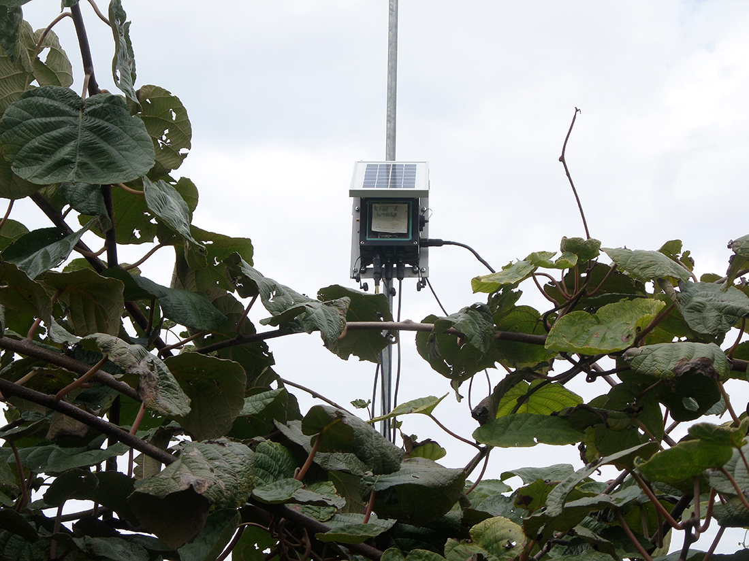

For this project, the company has installed **two different wireless sensors to monitor soil water status to plan irrigation** in a kiwi orchard. Data has been recorded with the same system but information has been transmitted to the platform by **two different wireless connection: GPRS and Sigfox**. The main aim has been testing reliability and costs during 2016 kiwi growing season.

Two Waspmote Plug & Sense! Smart Agriculture have been deployed with watermark sensors in different depths to control soil moisture with **fruit diameter sensor** to measure the size of the fruit; and **temperature and humidity sensors** to monitor environmental conditions. One of the sensor platforms is connected to a **GPRS shield and the other with Sigfox**. The first one represents the classical widely used data communication network and the second one the rapidly diffusing LPWAN technologies.

The information collected by the sensors has been sent to [esiFARM](http://www.famosasrl.com/en/" \l "project" \o "esiFARM" \t "_blank), FAMOSA’s platform, that includes both GPRS and Sigfox technologies. To manage GPRS stations however a server has had to be configured. In this case [Meshlium IoT Gateway](https://www.libelium.com/iot-products/meshlium/) has been used embedding Meshlium Management System making data handling easier. Farmers can get valuable information to schedule irrigation timing to avoid stress conditions, which is fundamental on kiwi plants.

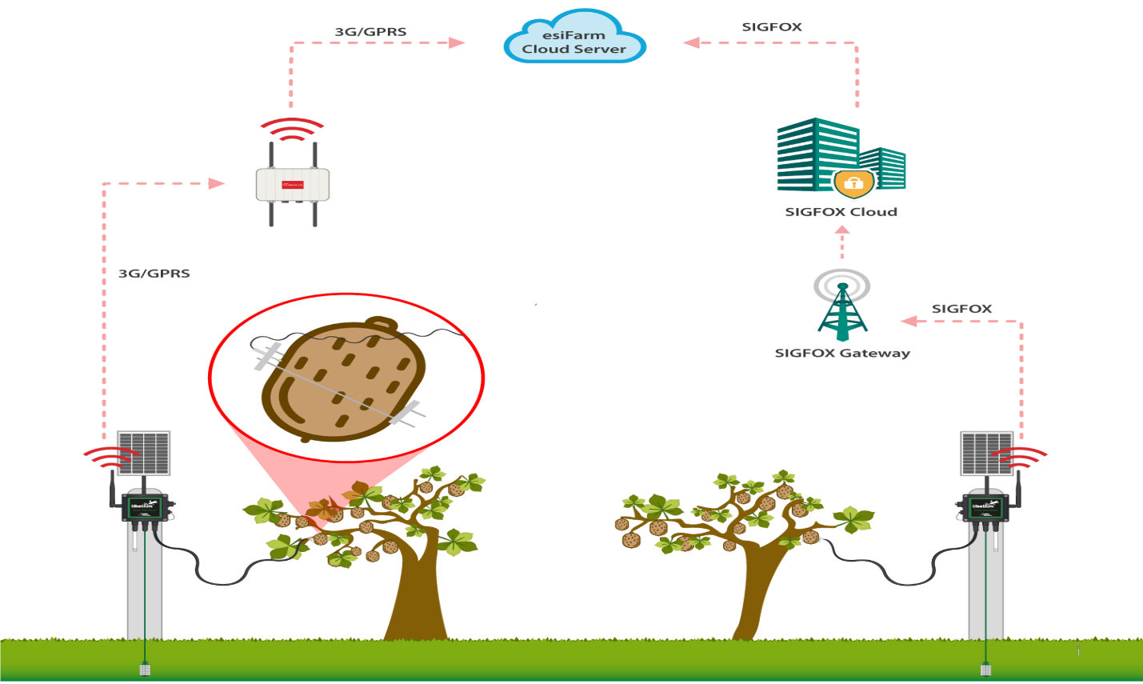

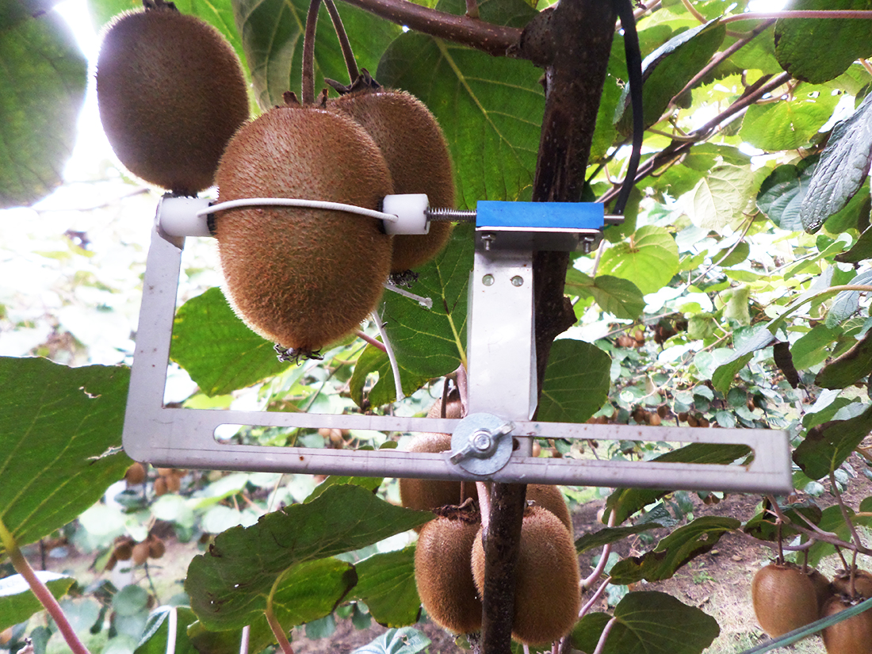

FAMOSA has detected **some differences between both technologies** after the deployment:

* + **GPRS**:
    - **A server is needed** to host data that has to be maintained by the local services.
    - There must be **GPRS/3G/4G coverage**.
    - It is needed power consumption hardware because GPRS node requires a **long-duration battery pack or external power supply**. The hardware needs to stay awake for a long-time and requires a longer communication session.
    - It **needs a SIM card** that usually takes some days to be activated. Even if international SIM cards are available, there is a strong dependence to a contract which make connections liable to changes and reliability.
  + [Sigfox](https://www.libelium.com/libeliumworld/sigfox-connectivity-waspmote-868mhz-europe-900mhz-us-long-range/):
    - It dumps data to a unique service which is **accessible worldwide**: data can be managed autonomously or by an intermediate service.
    - Coverage is already diffused in Italy so **it is not available everywhere** although it is rapidly growing worldwide.
    - It doesn’t need a handshake step with the network, while **based on an acknowledge response**.
    - Communication is very short and allows the device to stay dormant for a long time allowing a **much longer duration to batteries**.
    - **Registration is quicker than GPRS**, based on an annual fee.

**The final user has not been aware nor suffered the difference** between the communication through GPRS or Sigfox. Battery pack proved to have a **life long enough to cover the season** both in Sigfox and GPRS devices. In general, any field deployment should be **as simple as possible** and have a ready and reliable answer during installation tests.

**Precision Farming to make smart irrigation decisions**

Developing technological projects in rural areas may involve several difficulties because of the **absence of physical communication infrastructures and the costs which are often unaffordable**. However, wireless sensor networks suppose a great opportunity because of the **low installation, maintenance and also operative costs**.

FAMOSA is collaborating with farmers to introduce the IoT approach with esiFARM in their fields. The platform allows to **collect information from the sensor platforms and other information sources** such as georeferenced cameras pictures or multispectral analysis of satellite imagery. EsiFARM includes models to **help farmers in decision and alerts** (irrigation, pathogens and maturation).

“Farmers were impressed by the ease of the installation, which proved to be able to **give real-time and comprehensive information** in less than one hour of full installation”. During 2016 season between March and October the decision support system has worked well and continuously. Farmers have been able to monitor without interruptions soil water status to have irrigation always under control.